Station 1: Drops on a Penny

Materials Needed:
- 4 pennies
- 4 eyedroppers
- Plain tap water
Directions:
- Be sure the surface of each penny is completely dry.
- Predict the number of drops of water you can drop on the penny. Record your prediction on your data sheet.
- Using the medicine dropper, very slowly add drops of water to the surface of the penny.
- Continue adding drops slowly until the water spills. As soon as the water spills, record the number of drops that the penny held before overflowing.
- On your data sheet, make a sketch of the side view of the penny with water on it just before it broke. You may add water drops again in order to see what to draw.
- The property demonstrated in this activity is surface tension. Label your sketch and copy the definition in the red box on the back of this sheet onto your data sheet
Clean Up:
- Dry the pennies. Clean up any spills and be sure all paper towels are thrown away.

Surface Tension

Surface tension is the force created by bonds between molecules at the surface of the water. Surface tension results from cohesion due to the polarity of water molecules.

Surface tension can be broken by breaking the bonds between water molecules.
Bonds can be broken physically, by using enough physical force to break through the bonds.
Bonds can also be broken chemically, by adding another substance to water that prevents bonds from forming as easily. The most common substance used to break bonds in water is soap.

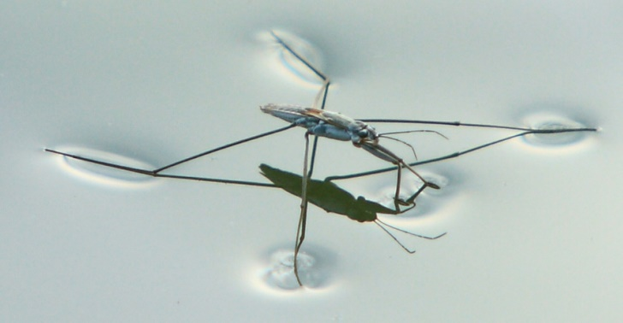
The surface tension of water allows this water strider to walk across the surface. He is not heavy enough to put enough force in one place to break through the bonds.

Station 2: Polar Pals
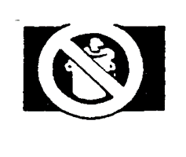
Materials Needed:
- 3 beakers
- Vegetable Oil (provided)
- Water (with green dye) (provided)
- Rubbing Alcohol (provided)
- 3 Popsicle Sticks for Stirring
Directions:
- Add half the oil and half the water to beaker 1
- Add the second half of the oil and half of the rubbing alcohol to beaker 2
- Add the remaining water and rubbing alcohol to beaker 3.
- Stir each beaker gently with different popsicle sticks.
- Observe what happens to each mixture. Record your observations in detail on your data sheet.
- The property demonstrated in this activity is the polarity of water. Copy the definition of polarity in the red box from the back of this sheet onto your data sheet.
Clean Up:
- Pour out Beaker 3 only. Pour Beakers 1 and 2 into the designated container at the front of the room. Do NOT pour any oil down the sink drains!

Polarity

Polar molecules are positively charged on one side and negatively charged on the other. This creates attraction between different molecules and helps form bonds to hold them together.

Water molecules are made up of 2 hydrogen atoms and 1 oxygen atom. Oxygen has a more negative charge. Hydrogen atoms have a more positive charge.
The resulting molecule is positively charged on the side with the hydrogen atoms, and negatively charged on the side with the oxygen atom.
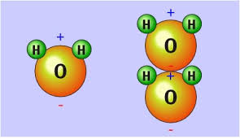
Polar molecules act much like magnets- the positive side of one molecule attracts the negative side of another, and vice versa.

Station 3: Density Column

Materials Needed:
- Density Column (provided)
  - Corn Syrup (dark brown)
  - Water (blue)
  - Hydrogen Peroxide (clear)
  - Vegetable Oil (yellow)
  - Rubbing Alcohol (green)
Directions:
- Observe the density column at this station.
- Sketch and label clearly the column onto your data sheet.
- This phenomenon is a result of each of these liquids having a different density. Copy the definition of density in the red box on the back of this sheet onto your data sheet.
- The density of each liquid is given on the back of this sheet under the definition. Write the density of each liquid beside its name on your diagram.
- Answer the question on your data sheet about the densities of each liquid.
Clean Up:
- No clean up necessary. Do NOT move or change the density column.

Density

Density measures how much matter is contained within a given volume. Density is calculated using the formula D = M/V, where D=Density, M=Mass, and V=Volume. The density of a given substance never changes, even when the mass or volume changes.

Densities of Common Substances

Water...................................... 1.00 g/cm³
Rubbing Alcohol..................... 0.79 g/cm³
Corn Syrup.............................. 1.37 g/cm³
Hydrogen Peroxide................ 1.45 g/cm³
Vegetable Oil.......................... 0.93 g/cm³

Station 4: Caterpillar Capillaries

Materials Needed:
- 2 Beakers
- Paper towel (provided; do not use the brown school towels)
- Plain tap water
- Red food dye
- Blue food dye
Directions:
- Fill each beaker halfway with water. When you are ready, raise your hand and have your teacher add food coloring to each beaker.
- Twist the paper towel into a long, thin strip.
- Place one end of the paper towel in Beaker 1 and the other end in Beaker 2.
- Observe the movement of the water through the paper towel. Write and sketch your observations on your data sheet.
- The phenomenon demonstrated in this activity is called capillary action. Record the definition in the red box from the back of this sheet onto your data sheet.

Clean Up:
- Pour out both beakers and rinse thoroughly. Throw away the paper towel. Wipe up any spills and leave the counter clean and dry.

Capillary Action
Capillary action is the rising or absorption of liquids through small gaps and holes in certain materials. Capillary action results from the interaction of cohesion between water molecules and adhesion of water to the material being used.

Paper towels absorb water and other liquids by utilizing capillary action to draw in water molecules and trap them in tiny holes in the material. Plants use capillary action to transport water up their stems- against the force of gravity- and spread water throughout the plant.

Station 5: The Great Race

Materials Needed:
- 4 eyedroppers
- 4 racing pages
- Plain tap water
Directions:
- You will only be using the top portion of the racing pages.
- Use an eyedropper to create a drop of water the size indicated on your sheet.
- Lift the sheet from the counter. Keeping the sheet flat, carefully tilt the page in each direction as needed, moving your water droplet through the course to the finish line.
- On your data sheet, record your observations about your water drop. Describe the shape of the drop as it moved. Also, tell whether it moved mostly as one large drop or if it broke into many smaller drops.
- The property of water you have observed is called cohesion. Copy the definition of cohesion in the red box from the other side of this page onto your data sheet.
Clean Up:
- Dry off every page and clean up any spills on the counter.
- Throw away paper towels.

Cohesion
Cohesion is the ability of water molecules to “stick” to each other. Cohesion is the result of bonds that form between the same type of molecules or material.

Cohesion is a major force at work in surface tension, the formation of ocean waves, and capillary action.

